**Back Propagation**

|  |  |  |  |  |  |  |
| --- | --- | --- | --- | --- | --- | --- |
| **Activation Function** | **Train Accuracy** | **Test Accuracy** | **LR** | **Epochs** | **#Layers** | **#HiddenNodes** |
| Sigmoid | 97.7 | 98.3 | 0.1 | 30 | 1 | 10 |

**Train ScreenShot:**

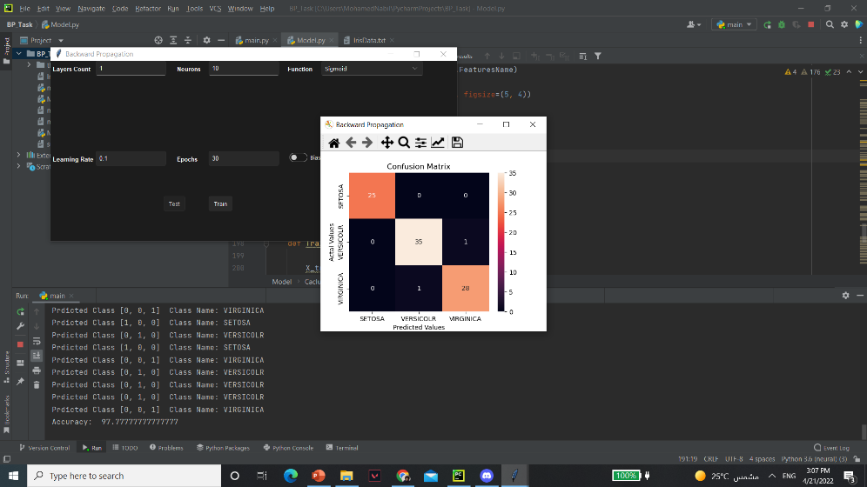

**Test ScreenShot:**

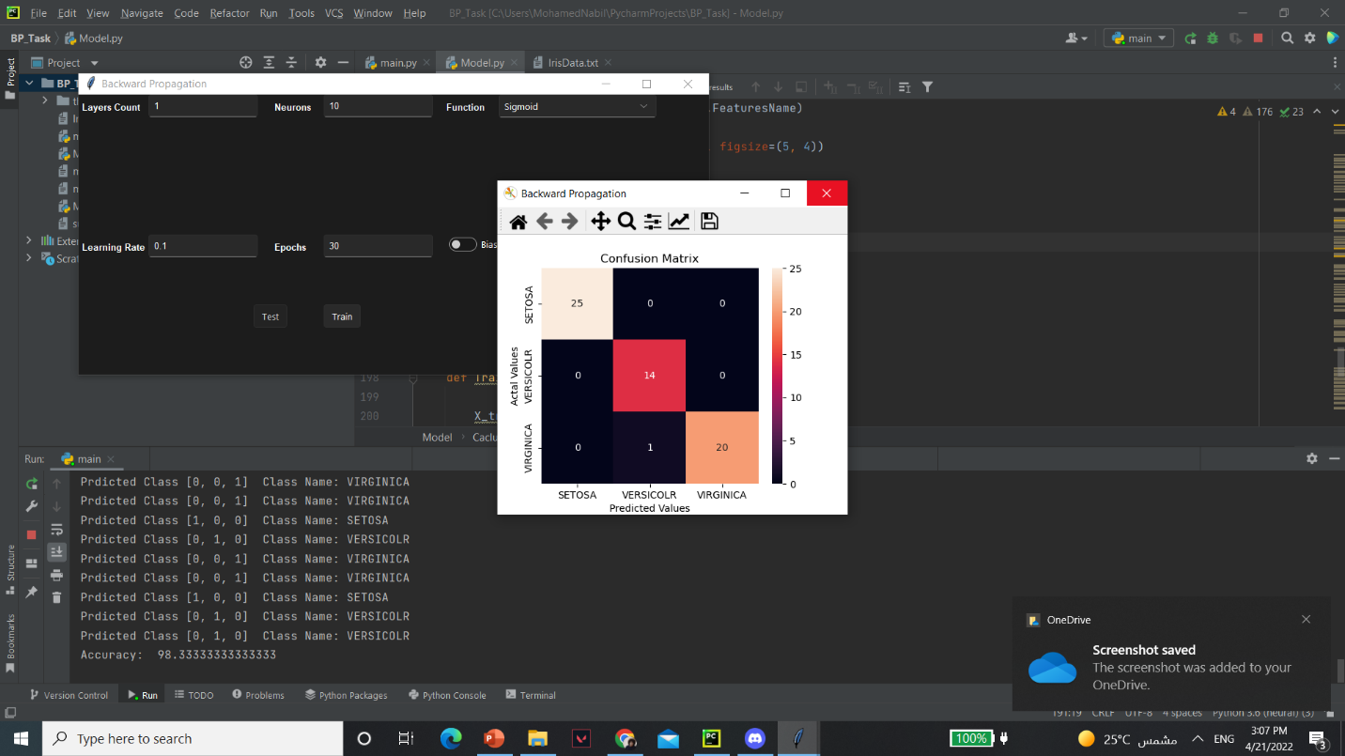

|  |  |  |  |  |  |  |
| --- | --- | --- | --- | --- | --- | --- |
| **Activation Function** | **Train Accuracy** | **Test Accuracy** | **LR** | **Epochs** | **#Layers** | **#HiddenNodes** |
| Hyperbolic Tangent sigmoid | 96.7 | 100 | 0.01 | 30 | 1 | 10 |

**Train ScreenShot:**

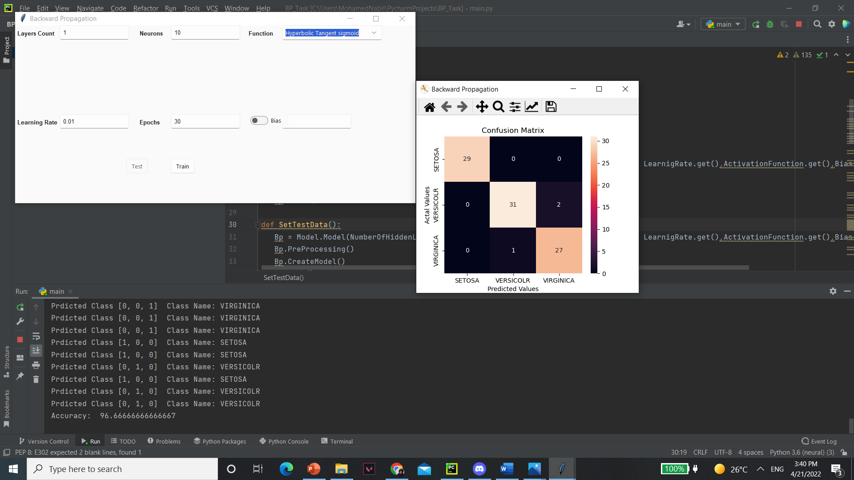

**Test ScreenShot:**

